|  |
| --- |
| Test Scenario 1 |
|  |

|  |
| --- |
| Test scenario 2 |
|  |

|  |
| --- |
| Test scenario 3 |
|  |

|  |
| --- |
| Test Scenario 4 |
| AB Is not an state series it should not take ab21ab1010 as a valid vehicle number |

|  |
| --- |
| Test scenario 5 – with invalid inputs |
| Test scenario 5 test with invalid input |
|  |

Test scenario 7

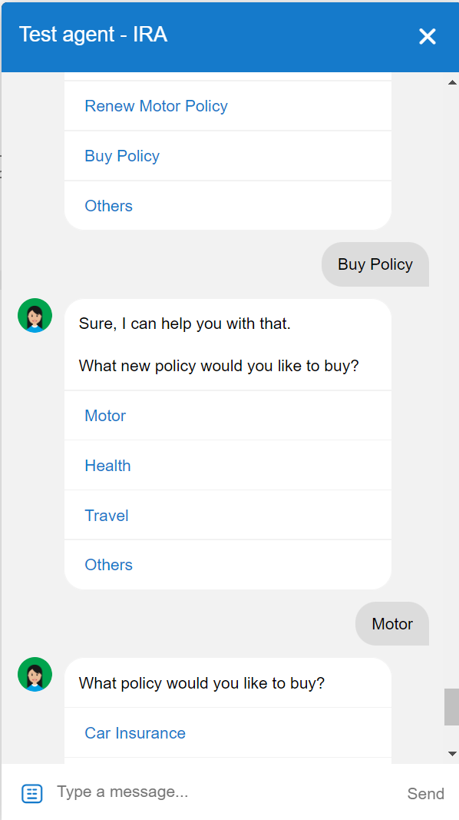

Test scenario 7

